**Ajax**-отправка письма на указанный **email** подписки (пока без валидации и записи в БД (реализация позже)).

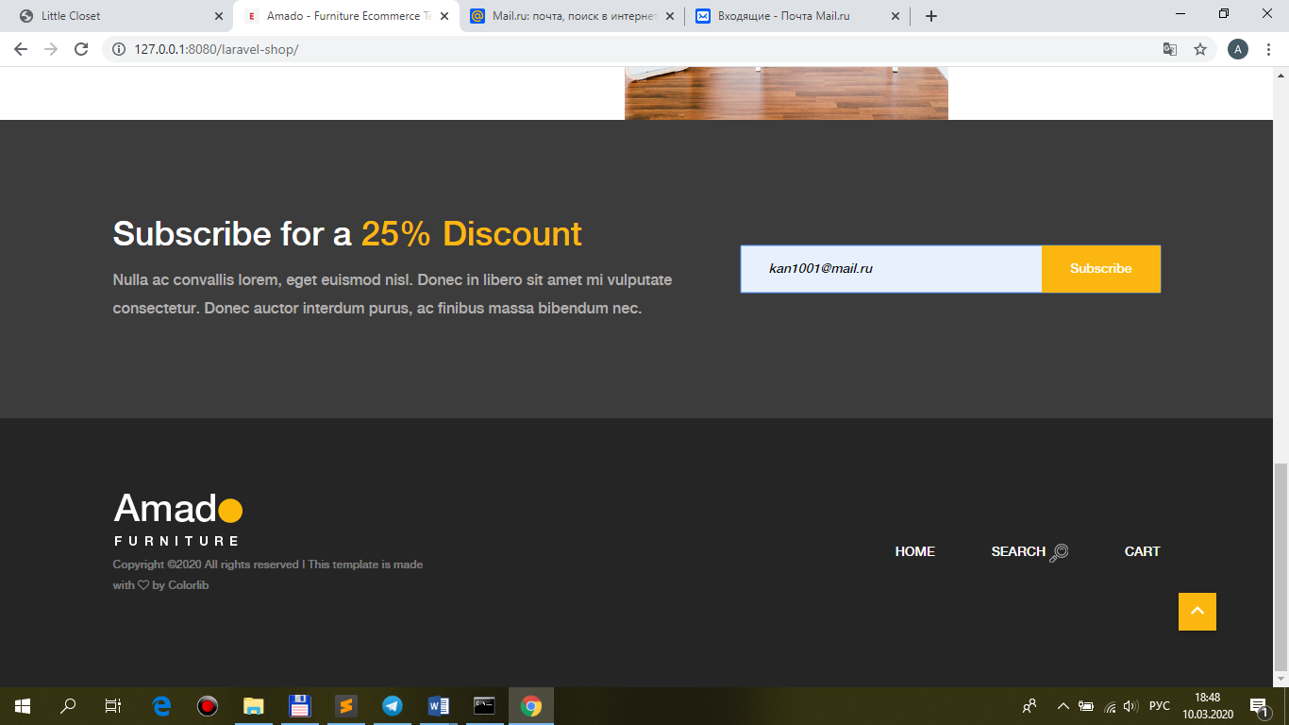

1.Установить библиотеку **guzzle**.

**composer.json**

"require": {

…

**"guzzlehttp/guzzle": "^6.3"**

},

resources\views\**shop\layout.blade.php**

**<!-- My customer js -->**

**<script src="{{ asset('public/js/main.js') }}"></script>**

(**закомментировать** index.blade.php, product.blade.php, cart.blade.php (**где есть**))

<form action="#" method="post">

<input type="email" name="email" **class=**"nl-email **text_substribe**" placeholder="Your E-mail">

<input type="**submit**" **class="button_substribe"** value="Subscribe">

</form>

**public\main.js**

$.ajaxSetup({

headers: {

'X-CSRF-TOKEN': $('meta[name="csrf-token"]').attr('content')

}

})

**$(document).ready(function(){**

**$('.button_substribe').click(function(){**

**BaseRecord.mailer($('.text_substribe').val());**

**return false;**

**});**

**});**

var BaseRecord={

…

**mailer**: function(value){

var ajaxSetting={

**method: 'post',**

**url: './mailer',**

**data: {**

**email: value,**

**},**

success: function(data){

**//alert(data.answer);**

**var data_json=JSON.parse(data.answer);**

**if(data_json['mail']) alert('We sent a message to your email!');**

},

};

$.ajax(ajaxSetting);

},

**roures\web.php**

Route::**name('mailer')->post('/mailer', 'ShopController@mailer');**

**app\Http\Controllers\ShopController.php**

/**

* Mailer of sending message.

*

* @return \Illuminate\Contracts\Support\Renderable

*/

public function **mailer(Request $request, ShopRepository $repository)**

**{**

**return $repository->mailer($request);**

}

**app\Repositories\ShopRepository.php**

/**

* Mailer of sending message.

*

* @return \Illuminate\Contracts\Support\Renderable

*/

public function **mailer($request)**

**{**

**$title = 'Message of your registration - ' . date('d-m-Y H:i:s');**

**$message = 'You has been successfully registred!';**

$client = new \GuzzleHttp\Client([

'headers' => [

//'Authorization' => '9267585bb333341dc049321d4e74398f',

//'Content-Type' => 'application/json',

]

]);

$response = $client->request('GET', 'http://api.25one.com.ua/api_mail.php?email_to=' . **$request->email** . '&title=' . $title . '&message=' . $message,

[

//...

]);

//return json_decode($response->getBody()->getContents());

return response()->json([

'answer' => $response->getBody()->getContents(),

]);

}

